|  |  |
| --- | --- |
| Submitted by |  |
| Phone |  |
| Email |  |
| Address |  |
| City/State/Zip |  |

**Prices:**

**T-shirt:** $25.00 (sizes XS-3XL)

Color: Olive Tri-blend (as shown)

**Crew Sweatshirt:** $40.00 (sizes XS-2XL)

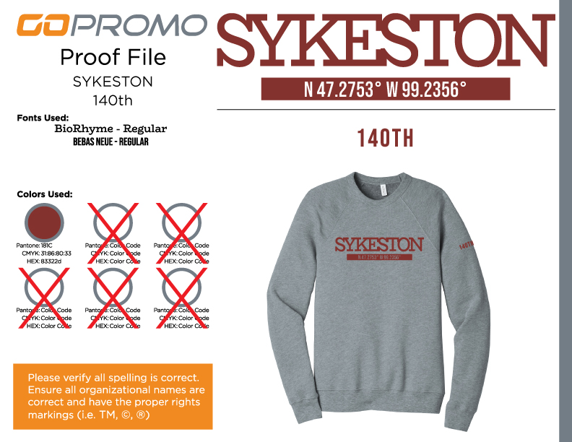Color: Athletic gray (as shown)

|  |  |  |  |  |  |
| --- | --- | --- | --- | --- | --- |
| Description | Size | | Quantity | Unit Price | Amount |
| XS/S/M/L/XL/XXL/XXXL | |
|  |  | |  |  |  |
|  |  | |  |  |  |
|  |  | |  |  |  |
|  |  | |  |  |  |
|  |  | |  |  |  |
|  |  | |  |  |  |
|  |  | |  |  |  |
|  |  | |  |  |  |
|  |  |  |  | Total |  |